**Tell us what your idea is.**

With Google’s current efforts to make android more accessible to people with various disabilities with projects like Project Euphonia, it appears to be the best time to push accessibility features for people with full body paralysis. My idea involves using cameras on device to help people who are unable to navigate android’s interface because of movement limitations in their bodies.

The camera would continuously take a video input, which will be used to identify small voluntary movements that the person is able to do and map those movements to different navigation actions. As these movements might be very small, the input video can be overlaid by a noise vector. Any movement in the noise vector would propagate the disturbance across the vector field creating a larger “movement” and hence would be suitable for a machine learning model running on the device.

The model can be fed a more coarse dataset as input because the movements would be derived from propagation in the noise vector field, rather than pixel disturbances in the video feed. Hence, the model would process a smaller input and therefore could be deployed even on weaker devices. Further enhancements could be made by using eye tracking to mark a position on the screen.

Android as an OS is now, more than ever before, opening new possibilities for its users, therefore the community should now also focus on making Android more accessible to a wider audience.

**Tell us how you plan on bringing it to life.**

Currently this project is in experimental phase, where I have been trying to make the noise vector field to respond to minor changes in pixel values. Also working on differentiating an intentional movement to an involuntary movement or some other noise in the vector field.

Google has been working with various health institutions around the world to make its products help a wider audience. An exposure to such institution knowledge would help shape the project fundamentals. Dataset collected from people with various movement disabilities is the key to this project’s success and hence Google’s involvement here becomes critical. Further, I would like this project to cater to people having a lower end device and hence a more robust understanding of Android as an OS and Tensorflow Lite becomes critical.

**Timeline:**

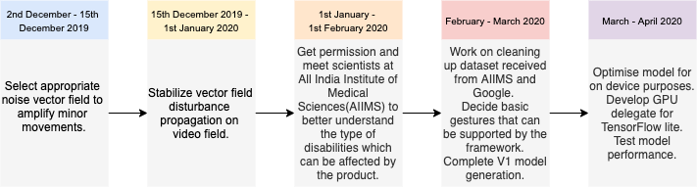

**Tell us about you.**

I currently work as an Engineer at PhonePe, India (An app-based payment company). I lead the on device machine learning team and am currently working on developing an inhouse end to end pipeline to serve machine learning models to the edge. We as a team are also tackling fraud detection on device.

Previously, during my bachelor degree, I have worked with Government of Sikkim, India to develop a phase change solar collector to provide heated air to houses in remote villages in Sikkim.

I completed my Masters from University of Washington, Seattle, where I worked on simulating battery performance for various stoichiometric composition of Li-ion batteries. Further, I also worked on deploying genetic algorithms completely on GPU using Nvidia’s CUDA architecture.

Also worked on an Electric Vehicle with its secondary source of power being solar. The vehicle was equipped with an intelligent roof which would incline a maximum of 5 degrees to align itself to the solar irradiation based on its availability to maximize output. Deployed the Tensorflow model on Nvidia’s Jetson to achieve the roof intelligence.